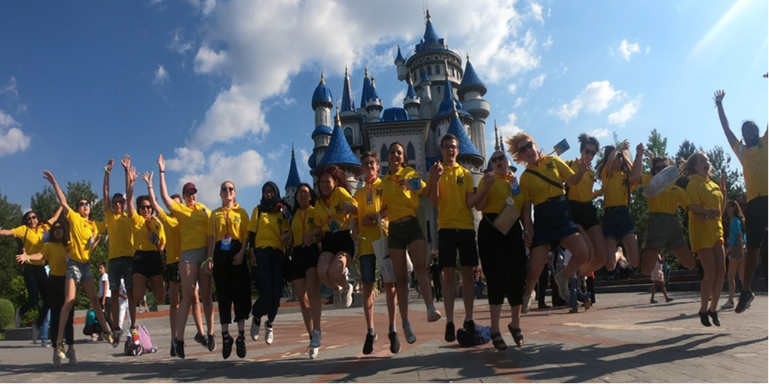
XXXXXXXX Lions Club offers local youths the chance to travel abroad in 2027
XXXXX Lions Club is now accepting applications for anyone who lives, works or attends a school or college in the XXXXXX area for a place at a Lions International Youth Camp abroad next summer (2027).
Every year over 100 International Youth Camps will be arranged by Lions International spanning 40 different countries. Every Lions Camp is different and exciting and offers everyone participating a life changing experience; to explore the culture and sights of that country; to be more independent; and to make new friends around the world. Commonly, those taking part will only need to raise enough funds for their flights and spending money with Lions Clubs in the country they are visiting meeting other expenses. This wonderful scheme underpins the global nature of Lions International with friendship and inclusivity at its very heart.
Every trip is unique, and each young person will spend up to 2 weeks living with a host family and then a further week to 10 days at an international youth camp comprising young people from around the world.
If you are aged between 16 and 22 and wish to apply for an international lions youth camp abroad in the summer of 2027, please contact xxxxxxxxxx Lions Club at (insert web address) or call us on (insert club telephone number)
Xxxxxxx Lions Club is one of 46,000 clubs operating worldwide. Anyone can join as a volunteer, and all are welcome. To find out more about what we do contact us at xxxx

