Lions International Youth Camp and Exchange Programme
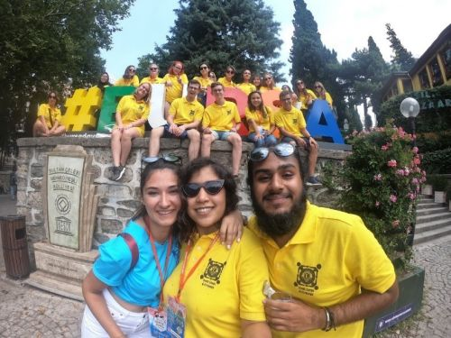

Would you like the chance to; spend next summer in another country of your choice; attend an international youth camp abroad; experience what it is like living with a host family in that country; and having the opportunity to make new friends with people your own age from around the world? If so then read on.....

(insert name of club here) Lions Club is now accepting applications for anyone aged between 16 and 22 who currently lives, works or attends School/College in the (insert name of your area here) area and who wants the chance to join The Lions Youth Camp & Exchange Program for 2027.

If you are interested then simply download and print the application form available below, complete all sections, ask a referee to complete their part, and then sign the declaration. The closing date for the receipt of applications is (insert date here).

To download a Youth Camp and Exchange Factsheet click HERE

To download an application Form click HERE

One of the principal aims of Lions Clubs International is to create and foster a spirit of understanding among the peoples of the world. This is in part achieved through their Youth Camp & Exchange Program which has been in operation since 1961. Anyone interested in this program or any other of the many service projects being undertaken by (insert name of club here) Lions Club should call us on (insert telephone no. for club here) or contact us HERE (could include a link to the contact us section of website) for further information.

The completed and signed document can then either be scanned and sent back electronically to steve.sherring@randflions.org.uk or printed and posted to the following address:

LIONS YOUTH CAMP & EXCHANGE

(insert name and address of club here)

.

Lions Clubs International currently has over 1.4 million members worldwide. Each year, the Lions International Youth Camp and Exchange Program introduces thousands of young people to life in other cultures by offering them the unique experience of living with a host family in another country and then joining an international youth camp in that country. Each year over 100 camps are available to choose from around the world. Where will you want to go?

Essential things you need to know

Exchanges can last anywhere between 2-6 weeks during which you will have the opportunity to stay with one or more host families in another country and attend an international youth camp in that country. All of your accommodation and usually all of your food and scheduled travel within your chosen country will be met by the Lions Organisation.

Youth camps are 1-2 weeks long and bring together young people from around the world where you will get the chance to learn more about the host country, make new friends, and embark on exciting activities, visits, and experiences.

Every participant in the scheme must have their application first endorsed by their local Lions club which is why (insert name of club here) Lions are now accepting applications for 2027. All applications must be received by (insert closing date here) and every shortlisted candidate will be invited to an interview along with their parent(s(/guardian(s).

Every applicant must live, work or attend school/college in the (insert the name of your area here) area, be aged between 16 and 22, have a referee to support their application and demonstrate excellent maturity, enthusiasm, international tolerance, and understanding.

(insert name of club here) Lions Club reserves the right to decline any application without explanation or any right of appeal.

You will be responsible for financing your own international travel to and from your country of choice, any camp fees (some but not all camps may charge a fee), and any spending money for things such as long-distance telephone calls, incidentals, and gifts.

You will be responsible for ensuring that you have all appropriate passports and visas, and are fully insured to cover all contingencies including trip cancellation, repatriation, accidents, medical expenses, personal effects, and personal liability during the entire duration of your travel and visit in the accepted country.

Remember that you are always representing (insert name of club here) Lions Club, your town, your community, and your country whilst in the host country. We will expect you to act appropriately and conduct yourself professionally at all times.

You must agree to abide by the policies of the Lions Youth Camp & Exchange Program. Your participation in the program is not for tourism, formal education, or employment. Any unauthorized extended personal travel or leaves of absence during the program are prohibited, and you are not to operate a motor vehicle or motorcycle during your stay in the host country. Any serious violation of the program's policies can, at the discretion of the host Lions officer, result in the immediate termination of your visit at your own expense.

