LIONS CLUBS INTERNATIONAL

Lions Young Leaders in Service Awards

CHALLENGING YOUTH TO SERVE

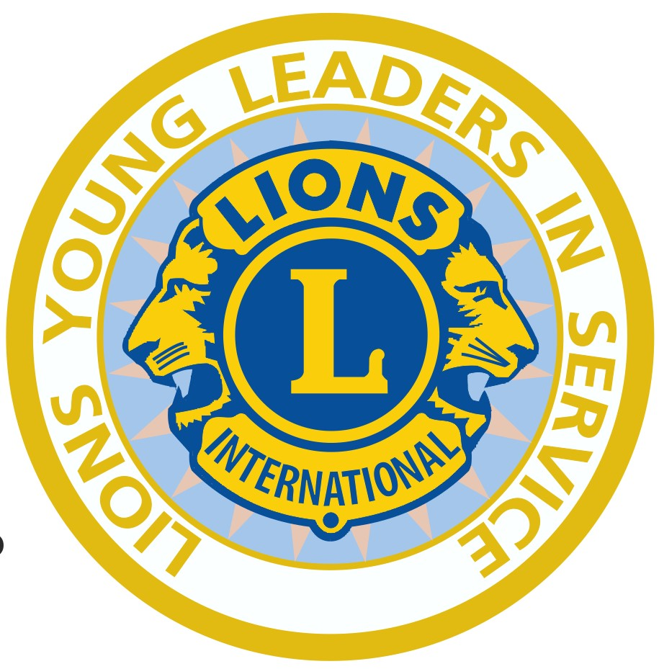

MD 105 LIONS CLUB GUIDE

MD 105 LIONS CLUB GUIDE

CONTENTS

Introduction to the award page 3

Benefits for young people page 3

Benefits for Lions Clubs page 3

Suggestions for projects page 3

How to get involved page 4

The Presentation Ceremony page 5

Press Release page 6

Registration and Request Forms pages 7 – 12

Consent form for use of images page 13

YOUNG LEADERS IN SERVICE AWARDS
Encouraging, guiding and mentoring young people – investment's for the future.

- Introduction to the award
The YLiS Awards recognise young people between the ages of 11 and 18 for their community service over 12 months, starting on the date of their first hour of community service and completing on the first anniversary of that date:
- 12 months community service of 25– 49 hours = Bronze Seal Award Certificate
- 12 months community service of 50 – 99 hours = Silver Seal Award Certificate
- 12 months community service of 100 or more hours = Gold Seal Award Certificate

On completion of 12 months' service the young leaders will receive a certificate, congratulatory letter from the Lions Clubs International President and a YLiS pin or cloth badge. These are requested on the anniversary of the 1st date in the logbook. Only one certificate can be issued in any 12 month period.

- Benefits for young people
- Experience the rewards of community service
- Become involved in their community and with local Lions clubs
- Receive an international award

- Benefits for Lions Clubs
- Experience the rewards of supporting young people with minimal costs
- Gain publicity from YLiS activities
- Increase the profile of Lions in your community

Suggestions for projects
Projects | Suggestions for service activities
Service for the elderly | Performing simple home repairs and jobs around the house; running errands; chatting and being a friend; helping older people with IT skills
Service for children | Collecting and distributing toys or clothes  Reading stories and helping with homework  Visiting children in hospital  As a Guide, helping with Brownies, Rainbows; as a Scout, helping with Cubs, Beavers, perhaps sewing on achievement badges, as a Cadets helping at meetings
Environment | Plant trees, weeding flower beds  Clear litter
Service to the homeless/hungry | Collecting food, clothing and toiletries for donation to a local welfare centre; raising money to buy essentials for them to set up home; disaster relief
Safety training | Helping younger children learn about water safety, fire prevention, traffic awareness, bicycle safety
Service to parents and family | Caring for a disabled family member  Shopping and cleaning  Entertaining, chatting and motivating  Looking after younger brothers or sisters; babysitting
Education | Helping a child or adult to learn how to read and write, mentoring  Reading to those visually impaired or record stories for them to listen to
Public health | Assist with health screening  Collect used spectacles and hearing aids for recycling  Create awareness of AIDS, teenage suicide and substance abuse
Taking a leaders’ role | Cadets; Boys’ Brigade; St John; Red Cross; Church; Youth Club; Community youth group; involvement with any community activity
Helping the Lions | Fund-raising for local charities, welfare activities or disaster relief  Planning a party for children; organising a treat for older people; working as a member of the Lions team in whatever they do

- How to get involved and what is available to help clubs promote the award

- Gain the commitment of one of your Lions members to take responsibility for this young people’s programme

- Request copies from your District Officer or the MD Officer of
  - the club mini guide, and 'How the Award Operates'
  - promotional leaflets for distribution to local youth groups and schools
  - logbooks
  - posters

The leaflets can be personalised to your club, with space left for you to insert your club
and contact details prior distribution. See also the MD105 website www.lionsclubs.co
members area/youth/young leaders in service.

- Your club may run this award scheme at any time of the year, with participants starting on the date of their first hour of community service and completing on the first anniversary of that date.

- Contact your local schools and youth organisations, such as St John, Red Cross, Boys Brigade, Cadets, youth clubs, Scouts, Guides, churches, sports clubs, young carers, Youth Councils and all youth organisations. A personal pre-arranged visit could be the most effective way of gaining their interest.

- Explain how the Young Leaders in Service award works and what benefits it brings. Take all supporting paperwork with you, including all promotional materials, registration forms, YLiS School/Youth Organisation Award Certification form and logbooks for recording service activities. Confirm start and finish dates and mention that you will be planning presentation events for successful Young Leaders in Service to tie in with finish dates. (You would probably want to run these a number of times each year.) Keep in contact with the organisation to keep their interest, monitor progress and in case of queries.

- Contact participating organisations at least a month before each participant’s year end to ensure that the logbooks/youth organisation data sheet record, have been completed with the hours of service recorded and advise the date for collection with the YLiS 2 School/Youth Organisation Award Certification Forms (p9/10)

- Send the logbooks with the YLiS 2 School/Youth Organisation Award Certification Forms and YLiS 3 Lions Club Request Form (p11) to your District Officer who will apply for the letters, certificates and pins and/or cloth badges from the Multiple District Officer. These logbooks will be returned to the Lions Club to the given back to the participants. Allow at least 4 weeks for delivery of the Awards.

- On completion of the Awards prepare a Press release and send it to the local newspaper, your District Newsletter and to the MD105 YLiS Officer who will include it on the YLiS Facebook page. Let your District and the MD Officer know. Also contact the editor of the Lion Magazine.

- Make arrangements for the presentation ceremony.

- The Presentation Ceremony – aims and suggested format

- To recognise and reward young people for their commitment to community service.
- To raise the profile of your Lions Club and confirm Lions commitment to young people.

- Schools – at a school event at which parents, friends, teachers and governors are present.
- At a local Lions event, with invitations issued to Lions and their partners, local dignitaries like the mayor, MP, business people, all the family and friends of the participants and the organisations or individuals who have benefited from the community service.
- At a youth organisation’s own event, again so that the maximum number of people can be invited and involved.
- Press – invite the Press and provide them with a Press release explaining what the presentation is all about. Get permission from the young people’s parents/guardians prior to use of any of these photos.

- Present all the young people with their certificates, letters from the International President and pin or cloth badge.

Promotion at the presentation event: if possible, put up a display stand with information about the YLiS scheme and other Lions youth programmes, local contact details and leaflets to hand out.

Press release – an idea for you to adapt for your own purpose.

Lions Clubs International Young Leaders in Service – local students at …………………School (or name of the youth organisation) have spent hundreds of hours of their time helping a variety of different people in their local community. The Lions Club of ………………….. is delighted to welcome very special young people to a presentation ceremony to celebrate their achievements. The Young Leaders in Service Awards reward the very best young people between the ages of 11 and 18 with certificates signed by the Lions International President.

These remarkable young people are all involved in helping their community, in particular those less fortunate than themselves. They dispel the myth that all young people are trouble-makers. We are proud of their achievements.

To learn more about your local Lions Club activities and perhaps become involved, contact………………………….. or ring ……………………………..

YliS Forms

YLiS 1a – page 8 (registration form including presentation evening)

This form is given to each young person before they are issued with a logbook.
When the completed request forms are returned the young leaders receive their
logbooks in which to record their service during the following 12 months.

YLiS 1b – page 9 (registration form without presentation evening)

This form is given to each young person before they are issued with a logbook if your club is
not planning on holding a presentation evening. When the completed request forms are
returned the young leaders receive their logbooks in which to record their service during the
following 12 months.

Forms 1a/1b are kept by the club for reference and destroyed when they are no longer required

YLiS 2 – page 10/11
(YLiS School/Youth Organisation Award CERTIFICATION FORM)

Form YLiS 2 is completed by the school or youth group or the person verifying the
hours at the end of 12 months service. It is returned to the Lions Club with the logbooks
or with a printout of each young persons electronic record of hours.

YLiS 3 – page 12 (Lions Club Award Request Form)

Completed by the club and sent with the logbooks or data sheet and form YLiS 2 to your District Officer. Details of District Officers are in the MD Directory of Clubs & Officers
which is updated each year.

YLiS 4 – page 13 (Parental Consent Form for Use of Images of Children)

Suggest that this is sent to the parents with the registration form and a YLiS leaflet.

YLiS 1a

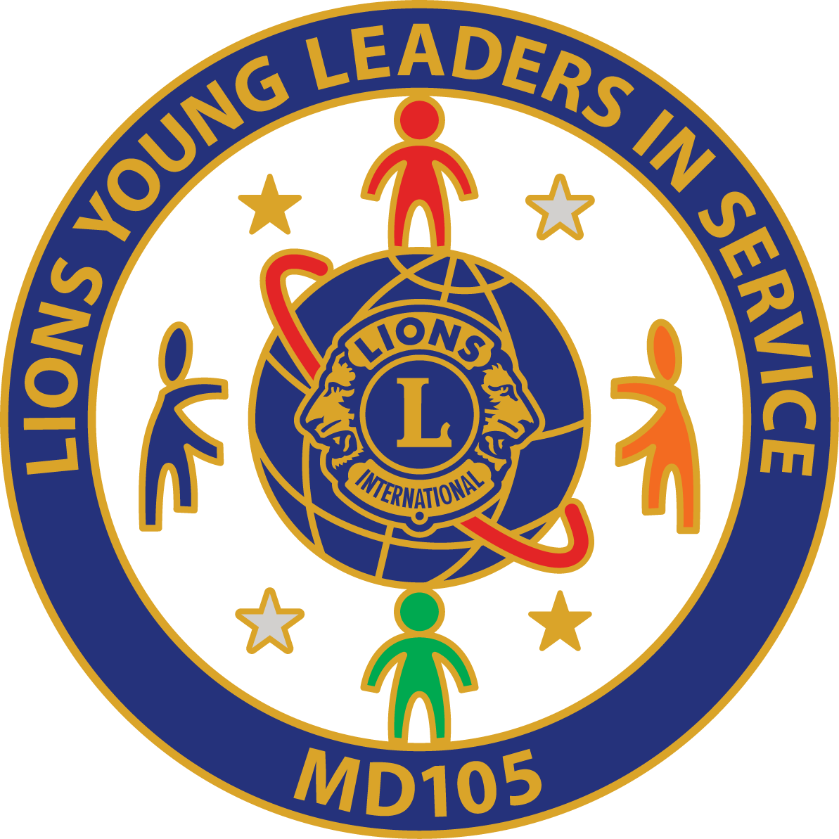

LIONS CLUBS INTERNATIONAL
YOUNG LEADERS IN SERVICE AWARDS

Thank you for your interest in becoming one of our “Young Leaders in Service”. Please complete this registration form and you will be given a Logbook, in which to record your 12 months of service, to start immediately. Young Leaders are people who love volunteering and helping others.

At the end of 12 months service to your community you will be awarded either a Bronze Award for completing 25 – 49 hours, a Silver Award for completing 50 – 99 hours or a Gold Award for 100 hours or more.

You can take part in different types of volunteering and all the hours you complete should be entered into your logbook and signed to confirm that you took part.
The categories are:
Environment, Literacy and Education, Help children, Help family and friends, Public health, Disaster relief, Help elderly people, Safety, Community Improvement, Helping homeless or hungry people, or any other service activity of your choice.

Your personal details:

Name................................................................................... Date of Birth.......................

Contact details: We would like your contact details so we can invite you to an Award presentation on the successful completion of your 12 months voluntary service. Leave blank if you do not wish to provide this information.

Address ………………………………………………………………………………………

........................................................................................................................................

…………………………………………………………………….…………………………….

Phone no….............................................. email............................................................

I confirm that the above information is accurate and that I wish to become a Lions Young Leader in Service.

........................................................................................................... Date............................................
Young Leader’s Signature

............................................................................................................ Date............................................
Parent/Guardian’s signature

Your Lions Club Representative is........................................................................................

Lions Contact Details.............................................................................................................

All personal data will be processed by Lions Clubs International in accordance with the Data Protection Act 1998
YLiS 1b
LIONS CLUBS INTERNATIONAL
YOUNG LEADERS IN SERVICE AWARDS

Thank you for your interest in becoming one of our “Young Leaders in Service”. Please complete this registration form and you will be given a Logbook, in which to record your 12 months of service, to start immediately. Young Leaders are people who love volunteering and helping others.

At the end of 12 months service to your community you will be awarded either a Bronze Award for completing 25 – 49 hours, a Silver Award for completing 50 – 99 hours or a Gold Award for 100 hours or more.

You can take part in different types of volunteering and all the hours you complete should be entered into your logbook and signed to confirm that you took part.

These categories are:
Environment, Literacy and Education, Help children, Help family and friends, Public health, Disaster relief, Help elderly people, Safety, Community Improvement, Helping homeless or hungry people, or any other service activities of your choice.

Your personal details:

Name................................................................................... Date of Birth….......................

Contact details: Leave blank if you do not wish to provide this information.

Address ………………………………………………………………………………………

........................................................................................................................................

…………………………………………………………………….…………………………….

Phone no….............................................. email............................................................

I confirm that the above information is accurate and that I wish to become a Lions Young Leader in Service.

........................................................................................................... Date............................................
Young Leader’s Signature

............................................................................................................ Date............................................
Parent/Guardian’s signature

Your Lions Club Representative is........................................................................................

Lions Contact Details.............................................................................................................

All personal data will be processed by Lions Clubs International in accordance with the Data Protection Act 1998
YLiS 2
YLiS School/Youth Organisation Award CERTIFICATION FORM to be completed by the school or youth organisation, after 12 months of service, using the information contained in the participants’ logbooks. Please contact your Lions Club representative at the end of 12 months for submission of the forms. Please type or print (using black ink) and make sure all information is legible. Lions Clubs International will use these completed forms to issue letters and certificates for successful award winners. All personal data will be processed by Lions Clubs International in accordance with the Data Protection Act 1998.

School/Youth Organisation or Leo Club Information
Name of organisation |  | Lions Club of
Address |  | Lions Club of
Address |  | Lions Contact
Tel. no. |  | Lions Contact
Email |  | Lions Contact

Award Certification
I certify that the information provided is complete and accurate.

_____________________________________________ Date ___________________________
Signed on behalf of the Youth Organisation

Please complete the following information for each student or group member who qualifies to receive a Lions Young Leaders in Service Award on completion of 12 months service to their community.

Young Person’s Information
Name  (as they would like to see it on the certificate) | Logbook or  data sheet |  | Total  Hours | Age | Young person’s signature | Choice of  Badge  (Metal or Cloth)
Name  (as they would like to see it on the certificate) | Start date | Finish date

YLiS 2 – YLiS School/Youth Organisation Award CERTIFICATION FORM contd.

School, Youth Organisation or Leo Club …………………………………...………………………………

Lions Club of …………………………………………...…………………….

Young Person’s Information
Name  (as they would like to see it on the certificate) | Logbook or  data sheet |  | Total  Hours | Age | Young person’s signature | Choice of  Badge  (Metal or Cloth)
Name  (as they would like to see it on the certificate) | Start date | Finish date

_____________________________________________ Date ___________________________
Signed on behalf of the Youth Organisation

All personal data will be processed by Lions Clubs International in accordance with the Data Protection Act 1998.
YLiS 3
LIONS YOUNG LEADERS IN SERVICE AWARDS
LIONS CLUB AWARD REQUEST FORM

To be given by the participating Lions Club to their District Officer for submission to Lions Clubs International MD 105

Lions Club of |  | District: 105
Town/City | Country
Name of Lion Submitting this form:

Telephone No: email:
Name and address to mail letters and certificates

Telephone No: email:

Instructions:

- Fill in all the information requested above.
- Ensure that all information on school/youth organisation award certification form (YLiS 2) is legible.
- Attach an original copy of the school/youth organisation award certification form (YLiS 2) for which you want letters and certificates issued. Attach the form to this page.

- Send the completed forms (YLiS 2 and 3) and the logbooks to your YLiS District Officer.
Logbooks will be returned to the club to be handed back to the Young Leaders.

Please allow FOUR WEEKS for the District and MD Officers to process these forms and issue a letter, certificate and pin or cloth badge for each award recipient. All letters and certificates will be mailed to the name and address provided above.

All personal data will be processed by Lions Clubs International in accordance with the Data Protection Act 1998.
YLiS 4
LIONS CLUBS INTERNATIONAL
MULTIPLE DISTRICT 105
Young Leaders in Service

Parental Consent Form for Use of Images of Children

I/we………………………………………………….……..… the parent(s)/guardian(s) of

Young person’s full name …………………………………………………………..

hereby give Lions Clubs International permission to use any still and/or moving image being video footage, photographs and/or frames and/or audio footage depicting my/our children named above, taken on behalf of the Lions Club of ………………………………………………,

on ………………………………………………………………….………….

at ………………………………………………………………………………
for any of the following uses:
Advertisements, marketing, leaflets, or any other use such as for training, educational or publicity purposes. The above consents will apply throughout the world and be for an indefinite period / to expire on (date)……………………………………..… (delete as appropriate)

Signed………………………………………....Date…………………………………

Signed………………………………………....Date…………………………………

Address………………………………………………………………………………

………………………………………………………………………………………...

Postcode………………………………..

All personal data will be processed by Lions Clubs International in accordance with the Data Protection Act 1998

