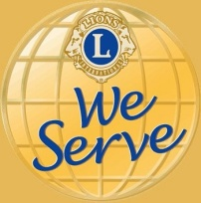
The International Association of Lions Clubs
District 105D
Incorporating Lions Clubs International District 105D Charitable Trust
Registered Number 1072984

District Governor 2018 - 2019 Lion Ken Staniforth

dg@lions105d.org.uk www.lions105d.org.uk

“Working Together for Those We Serve”

10th February 2019

Dear Presidents & Health & Safety Officers,

FOOD HYGIENE CERTIFICATION

Fellow Lions,

I am writing to let you know there has been a change in the way Lions may achieve this free course.

The Safer Food Company have recently been reorganised and access to the Level two Course (on preferential terms) for Lions Clubs is via Brian Dickety, MD Health & Safety Advisor briandickety@aol.com , as an interim arrangement.

The process is that should you need to take advantage of the reduced cost, then can you please furnish Brian with the name of the Student together with the name of his/ her Lions Club together with contact details. He will then obtain a unique number provider by Safer Food, which he’ll pass to the Student who needs to quote the unique number when booking the course on line.

We’ll inform you should the process change.

Regards,
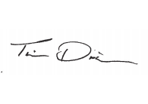

Lion Tim Dixon CMIOSH, MIFireE

District 105D Health & Safety Adviser

